Borrower: Mr. Boun Sovisith and Mdm. Siv Chantha

1. Mr. Boun Sovisith

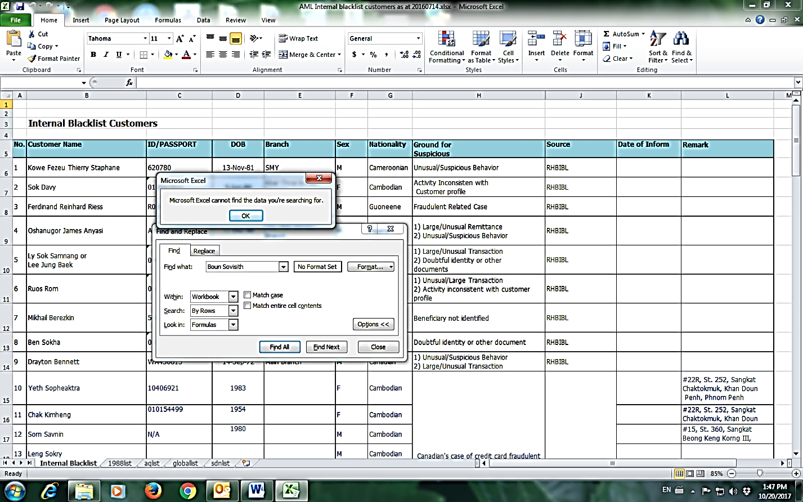

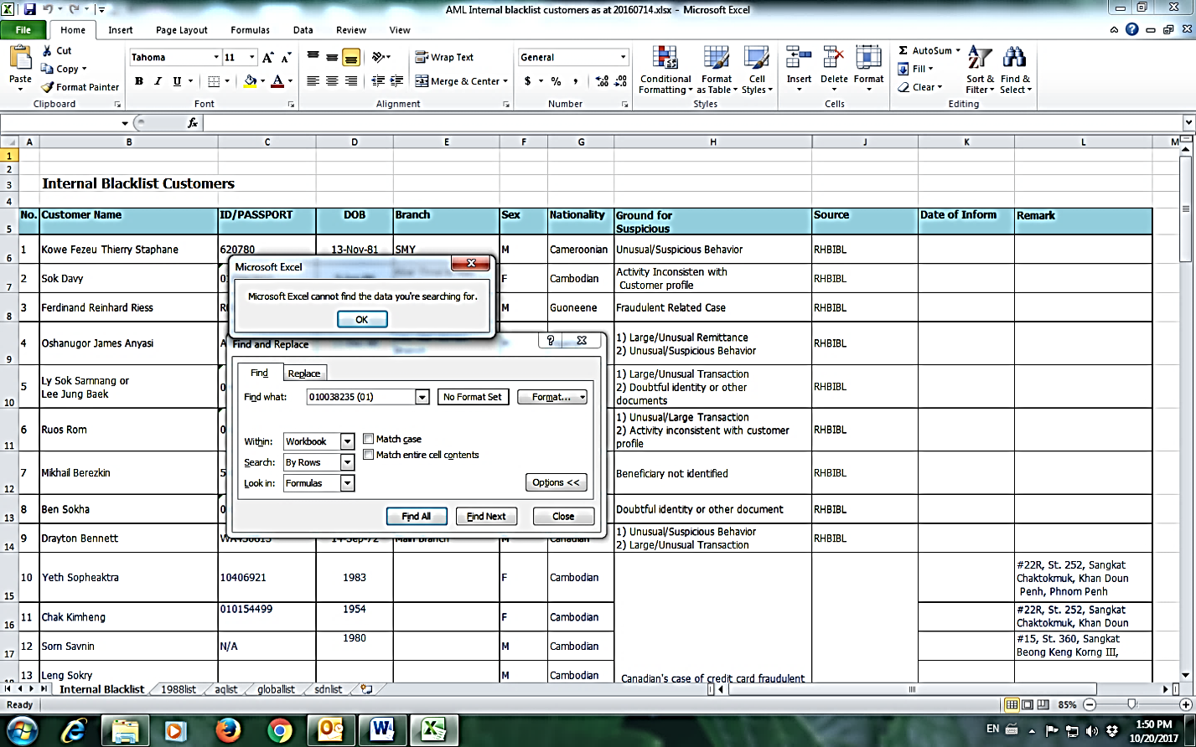

1. Mdm. Siv Chantha

